Sohan M
1NT19IS155

HIVE INSTALLATION

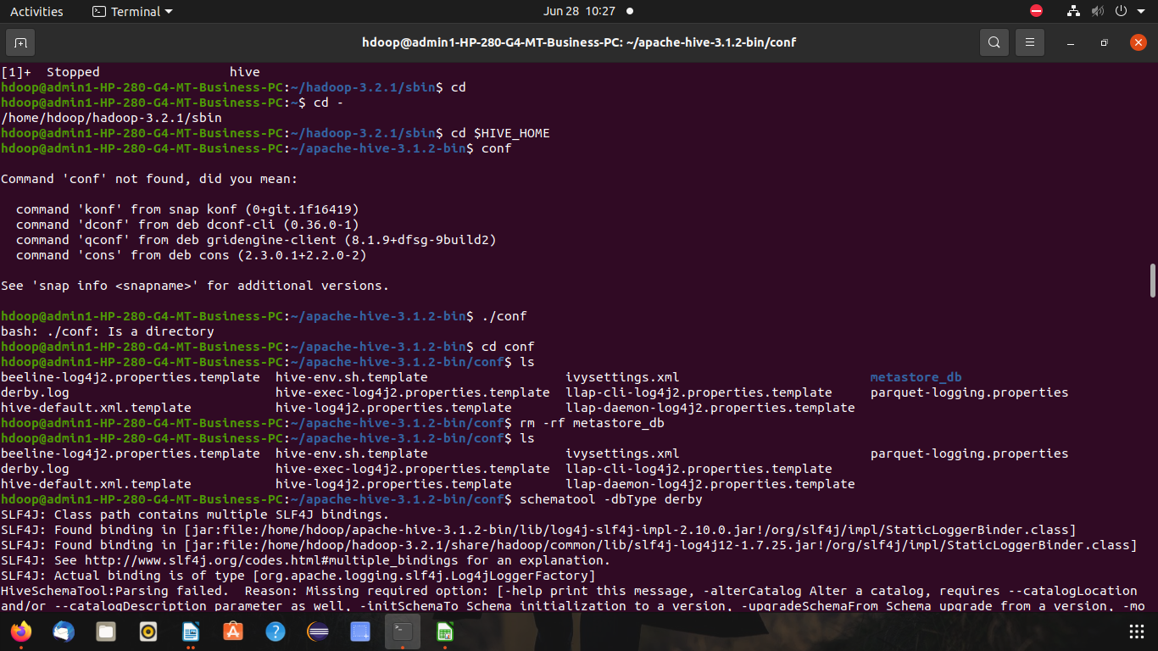
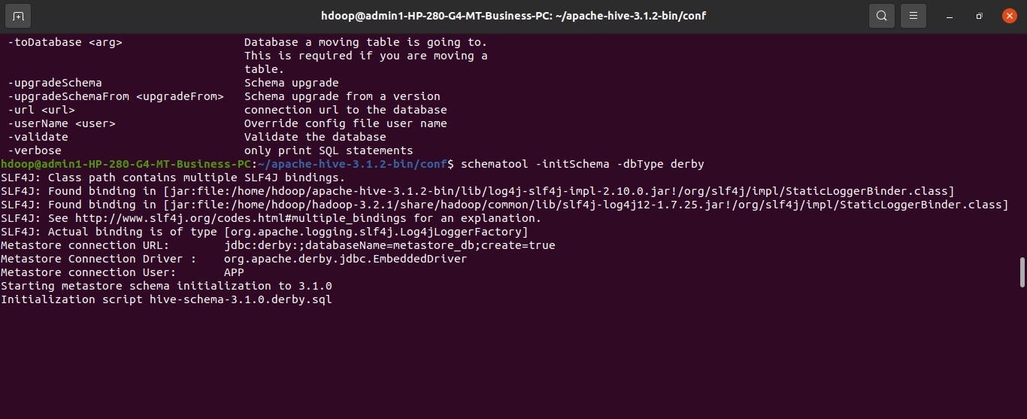
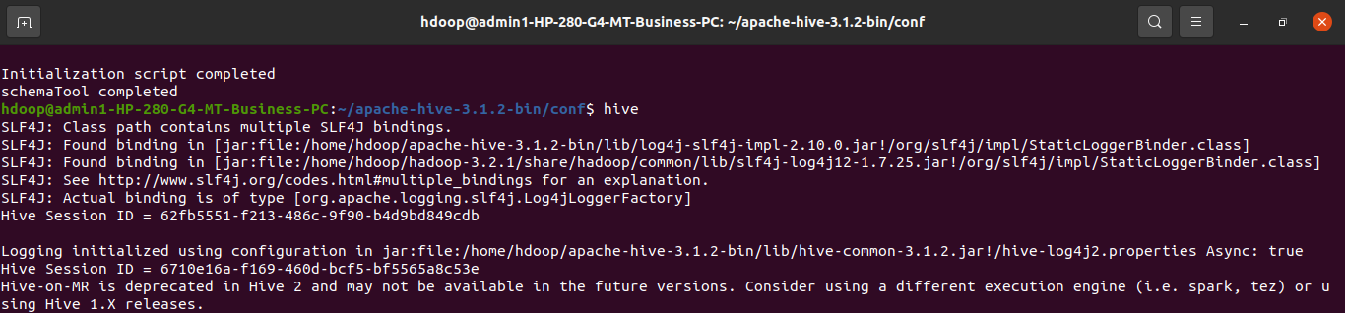

show databases;

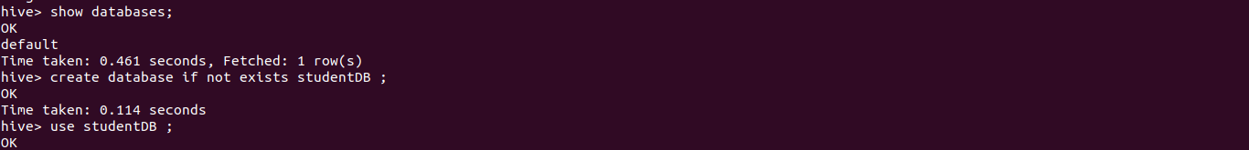
create database if not exists studentDB ;

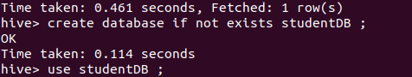

use studentDB ;



create table student(usn int, name string, age int) ;

show tables ;

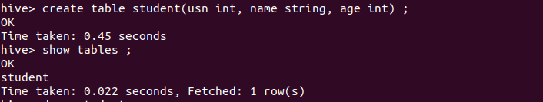
desc student ;

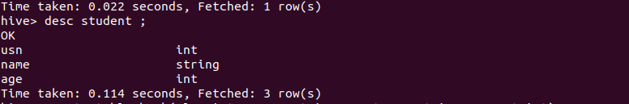

create table bank(slno int, cname string, custname string, amount int)
row format delimited
fields terminated by "," ;

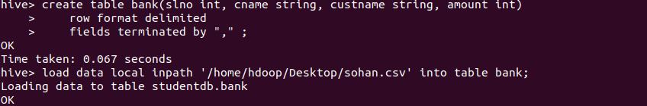
load data local inpath '/home/hdoop/Desktop/sohan.csv' into table bank;
select * from bank;

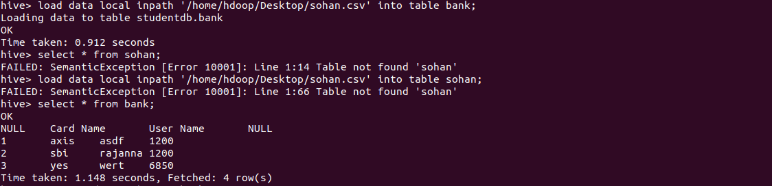
select max(Amount) from bank;

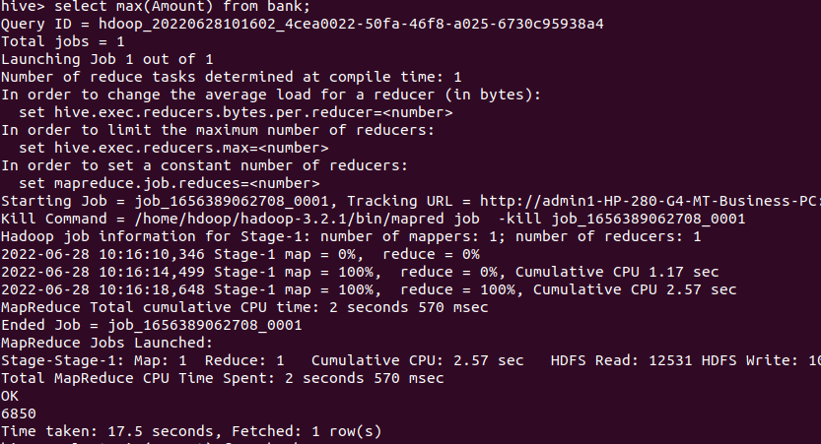

select min(Amount) from bank;
select avg(Amount) from bank;

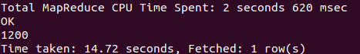

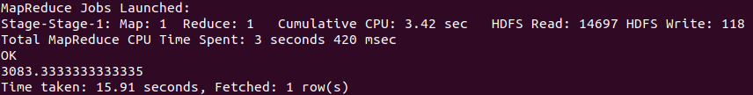
select count(*) from bank;

